

School of Informatics and Engineering

Digital Inspection and Measurements tool
by

Justas Bartnykas

A report submitted in partial fulfillment of the
requirements for the degree

Bachelor of Engineering (Honours)
in
Computer Engineering
in
Mobile Systems

Supervisor: Benjamin Toland
Submission Date: 14 / 03 / 2019

ABSTRACT
An abstract, or summary, in English not exceeding 300 words or one page in length, should precede the main text. The style of writing for this section is technical and concise, with economical use of words.

The summary should be regarded as an independent section which is meaningful when read in isolation from the remainder of the report. In writing the abstract, therefore, one should look at each completed section of the report, extract key statements, and present them as concisely as possible. The abstract should not include internal headings or parenthetical citations of items listed in the bibliography/list of references. Figures and tables should not appear in the abstract.

It should be written only when every other section of the report has been completed.

ACKNOWLEDGEMENTS
This page is optional. It is where you may put your personal word of thanks to anyone who helped you throughout your work.

DECLARATION

The work submitted in this report is the results of the candidate’s own investigations and has not been submitted for any other award. Where use has been made of the work of other people it has been fully acknowledged and referenced.

Student Name

______________

TABLE OF CONTENTS
ABSTRACT i
TABLE OF CONTENTS ii
LIST OF ABBREVIATIONS iii
LIST OF FIGURES iv
LIST OF TABLES v
Chapter 1 Introduction 1
1.1 Problem 1
1.2 Background 2
1.3 Scope and Objectives 2
1.4 Document Overview 2
Chapter 2 Literature Review 3
Chapter 3 Materials and Methods 4
Chapter 4 Results and Discussion 5
4.1 Results 5
4.2 Discussion 5
Chapter 5 Conclusions and Recommendations 7
5.1 Conclusions 7
5.2 Recommendations 7
REFERENCES 8
Appendix A Project Planning 9
Appendix B Salient Extracts from Project Diary 10
Appendix C Design Drawings & Component Specifications 11
Appendix D List of Software Code 12
Appendix E Relevant Standards 13
Appendix F Other Technical or Data Appendices 14

LIST OF ABBREVIATIONS
RAM Random Access Memory
PC Personal Computer

LIST OF FIGURES
Figure 1 System Overview 1
Figure 2 Sub-system Overview 2

LIST OF TABLES
Table 1 Experiment Trials 1
Table 2 Experiment Results 2

Chapter 1 Introduction
The first chapter sets the background and outlines the aims to the project, in form of Problem Statements (salient factors may include issues related to efficiency, economic, innovation or discovery, technical performance and challenges etc.), which culminates to specific statement of project objectives. Outline of uniqueness to the project, or importance/motivation factors is also desirable.

Problem
In your thesis/report, this is the introduction to your work where you describe the overall problem you are trying solve. This section should not assume that the reader has any knowledge of the specific area in which you are working or the specific tools, techniques, and methods you plan to use. You must explain everything to them. Figure 1 is an example of how to insert figures and use captioning. The figure itself should be centered and fall within the margins of the thesis/report.
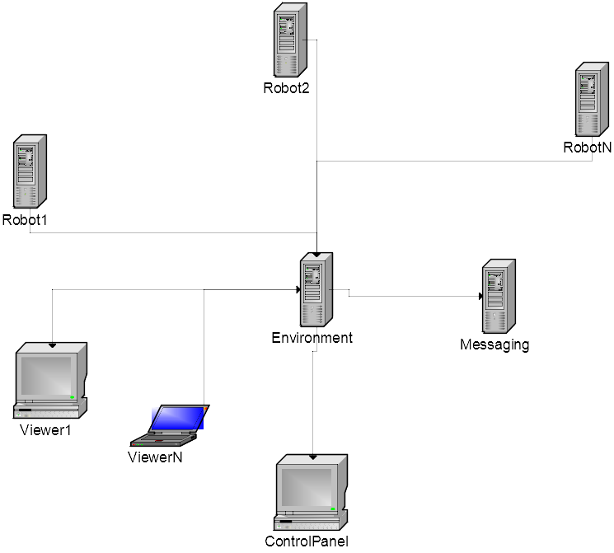
Figure 1. Simulator Deployment Overview

  - Background
Here you want to provide information that the reader needs to know before they can continue reading this paper. This is not necessarily the same as a literature review, which is placed in Chapter 2. If you are following the work of others, this is where you should place the basic information about that work and how your work fits in.
  - Scope and Objectives
In this section, you should define what you will and will not attempt to do in this research.
  - Document Overview
Here you are to give your reader a guided tour of the remainder of the document. It should be more than just a list of the upcoming chapters. You should effectively overview the background, methods, and results of your report in two or three paragraphs.
- Literature Review
This is essentially a review or presentation of the state-of-the-art in the respective project domain(s). Project methods are mapped or evidenced against current scientific (theoretical and experimental) and technical literature. Such literature may also be used to rationalise the choice of theoretical concepts, analytical methods, instrumentation, experimental design, and boundary conditions for the project.

Literature sources and other material included in your report should be cited using the Harvard Referencing System (Author, Date), and all the cited sources should be included in the References section of the report. Control the content of the review with both what is known and what is not known about your project. Move from the bigger picture and importance to your specific investigation.

- Implementation
The overall aim of this chapter is to provide a structured presentation of how the design project was implemented. It is intended to describe the tools and processes that enabled you to meet your stated project objectives.
This section will be read for at least two major reasons:
- A readers will judge how skilfully you have carried out your design and the empirical process of problem solving;
- Second, readers may want to test your methodology against your results in their own laboratories.

In the Materials and Methods section, clarity and accuracy should be your priorities; hence, extracts from your project diary (see section 3.4) should be at hand to support your descriptive statements. Some Goals of a Materials & Methods Section are therefore, to:
  - Present the design considerations, test/experimental design;
  - Provide enough detail to allow readers to interpret your results.
  - Give enough detail for readers to replicate your work.

- Results and Discussion
This section may also be presented as two separate sections of Results and Discussion. The convenience of whichever style to be adopted may vary from project to project (your supervisor will provide guidance on this).

The Results section is where data are presented as tables or figures and your should consider the following when writing this section:
(a) Decide which data are best presented in a tabular format and which are best presented in a graphic format⎯avoid presenting the same data in both formats;

(b) Summarize each data presentation by addressing the relevant trends or patterns that pertain to the project hypothesis or objective(s). These summaries should be written clearly and concisely, avoiding personal pronouns and excessive descriptive phraseology. Write quantitatively⎯ mention of terms more or less, doesn’t tell much. How much more or less? Use the data in your writing, such as, 65 percent of the ball bearings seized compared to only 45 percent of the roller bearings.

(c) Present the strongest, most compelling data first and the weakest, least compelling data last. When the sections are presented separately, do not make interpretations nor draw conclusions about the data in the Results section; this is left to the Discussion and Conclusion sections.

The Discussion section is where interpretations are made and conclusions drawn about whether the results support or fail to support your stated hypothesis. The following should be considered when writing this section:

(a) State the strongest, most convincing data of your argument in support or rejection of the hypothesis first, followed by progressively weaker evidence. Refer to your data presentations to provide evidence of your position;

(b) Include comments on how design inadequacies and experimental errors might have affected your results and what could be done to reduce them.

- If there has been similar research done by others, state how your work compares;

- State the relevance of the experiment to the field of research and where new directions of research might lead from this experiment

4.1 Results

4.2 Discussion

- Conclusions and Recommendations
Conclusions are often the most difficult part of the Final Year Design Project report⎯many students feel that they have nothing left to say after having written the report. However, you need to remember that the conclusion is often what a reader remembers best, hence, your conclusion should be the best part of your report.

The good Conclusion should review the entire project against your problem definition, aims and objectives, and evaluate project success and results. It may also include a section for suggestions for further work, or if these are many, then a Further Work chapter may follow the Conclusion. The following suggestions will ensure a good set of conclusions:

- Show why your project was important⎯ show that your project was meaningful and useful;
- Conclusions should synthesize, not just summarize⎯ contents in the main body of the report should not simply be repeated. You need to outline how the points you have made and the support and examples you used were not random, but fit together.
- Redirect your readers ⎯ Give the reader something to think about, perhaps a way to use your design/results in the "real" world. If your introduction went from general to specific, make your conclusion go from specific to general, i.e., think globally.
- Often the sum of a good final year design project is worth more than its parts⎯ By demonstrating how your ideas in the project have worked together, you can create a new perspective to similar applications.

  - Conclusions
  - Recommendations

REFERENCES

Use IEEE referencing.

- Project Planning
Salient components of the project planning should be described, and critically evaluated with suggestions for how the project planning could have been improved upon in case significant deviation from original plans had to be accommodated in the project. For example, indicate how your project monitoring or prescribed milestones raised any issues and if you needed to re-plan your project at any point(s).

- Salient Extracts from Project Diary
Present the salient extracts from your project diary over the two semesters.

- Design Drawings & Component Specifications
Drawings (sketches, mechanical, electronic drawings etc.) are necessary, as part of the design process, hence; layout drawings, detail drawings and assembly drawings, where possible, should constitute part of your design project report.

- List of Software Code
Where necessary, you should have only included selected code fragments or algorithm summaries in the main body of the report. Full listing which is part of the project may is not necessary for overall understanding of the report may be included here.

- Relevant Standards
Technical documents such as British Standards, DIN etc.

- Other Technical or Data Appendices
Technical documents such as standards, component specifications, formulae sheets and formulae derivations may be included in this appendix.

